

August 4, 2025

To: Wheat Breeders and Seed Producers:

Re: 2025-26 Kentucky Wheat Variety Trials.

Seven winter wheat trials (one forage trial and 6 grain) will be conducted at 6 locations. Trials will be conducted using intensive management practices in a randomized complete block design with four replications.

Grain trials will evaluate yield, test weight, plant height, lodging, heading date and disease reaction. The forage variety trial will evaluate forage dry matter yield potential at ~ milk stage. One grain trial will also be used to evaluate straw yield potential.

The fee is **$500** per entry for all trials. **12** pounds of high-quality seed is required per entry.

Seed treatment with fungicide and systemic insecticide is recommended. Seed treatment must be listed and treated at labeled rates. Entry forms and seed must be received by September 23, 2025.

Results will be published in the annual Kentucky Small Grain Variety Performance Trial report and available online at: [**varietytesting.ca.uky.edu**](https://varietytesting.ca.uky.edu/C:/Users/bruening/Documents/Adobe%20Captivate%20Cached%20Projects). If you need any additional information, please call 859-351-9236 or e-mail [bruening@uky.edu](mailto:bruening@uky.edu). Thank you for your cooperation and I look forward to working with you.

Sincerely,

Bill Bruening, Scientist

Wheat & Soybean Variety Testing

University of Kentucky

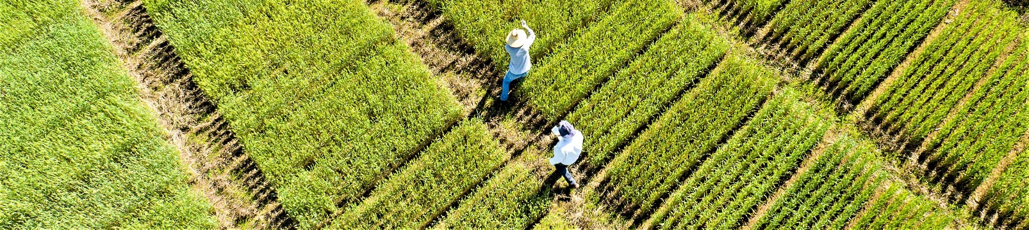

**2025-26 KENTUCKY WHEAT VARIETY ENTRY FORM**

Company: 

Submitted by: 

Email: 

Seven wheat trials (6-grain & one forage) will be conducted with 4 reps per trial. Varieties are additionally evaluated for straw yield and cover cropping/winter grazing potential and rated for disease reaction.

|  |  |  |  |
| --- | --- | --- | --- |
|  | **Brand/Entry Name(s)°** |  | **Seed Treatments** |
| 1 |  |  |  |
| 2 |  |  |  |
| 3 |  |  |  |
| 4 |  |  |  |
| 5 |  |  |  |
| 6 |  |  |  |
| 7 |  |  |  |
| 8 |  |  |  |
| 9 |  |  |  |
| 10 |  |  |  |
| 11 |  |  |  |
| 12 |  |  |  |
| 13 |  |  |  |
| 14 |  |  |  |
| 15 |  |  |  |

**° If *we have previously tested this entry under a different ‘experimental’ name, please indicate.***

Entry fee:  entries @ **$500** per entry = $  = Total Due

Send **12 lbs seed**, and **email** **entry form** by **September 23, 2025.**

Contact Bill Bruening for late entries/substitutions.

**Send seed to:**  Send check (payable to University of Kentucky) to:

**Bill Bruening** / Dock Attn: Bill Bruening

**N-122 Agriculture Science Center North** UK - Plant and Soil Sciences

**University of Kentucky**  425 Plant Science Bldg.

**Lexington, KY 40546-0091** Lexington, KY 40546-0312

Please email entry form to - [bruening@uky.edu](mailto:bruening@email.uky.edu) – (859) 351-9236