July 31, 2023

To: Wheat Breeders and Seed Producers:

Re: 2023-24 Kentucky Wheat Variety Trials.

Eight winter wheat trials (one forage trial and 7 grain [including a Metribuzin tolerance trial]) will be conducted at 6 locations. Trials will be conducted using intensive management practices in a randomized complete block design with four replications.

Grain trials will evaluate yield, test weight, plant height, lodging, heading date and disease reaction. The forage variety trial will evaluate forage dry matter yield potential at ~ milk stage. One grain trial will also be used to evaluate straw yield potential. Winter vegetative growth will also be measured to estimate cover cropping/winter grazing potential. The Metribuzin tolerance trial will also be conducted this year.

The fee is $500 per entry for all trials. 10 pounds of high quality seed is required per entry.
Seed treatment with fungicide and systemic insecticide is recommended. Seed treatment must be listed and treated at labeled rates. Entry forms and seed must be received by September 24, 2023.

Results will be published in the annual Kentucky Small Grain Variety Performance Trial report and available online at: varietytesting.ca.uky.edu . If you need any additional information, please call 859-351-9236 or e-mail bruening@uky.edu. Thank you for your cooperation and I look forward to working with you.

Sincerely,

Bill Bruening. Scientist
Wheat & Soybean Variety Testing
University of Kentucky

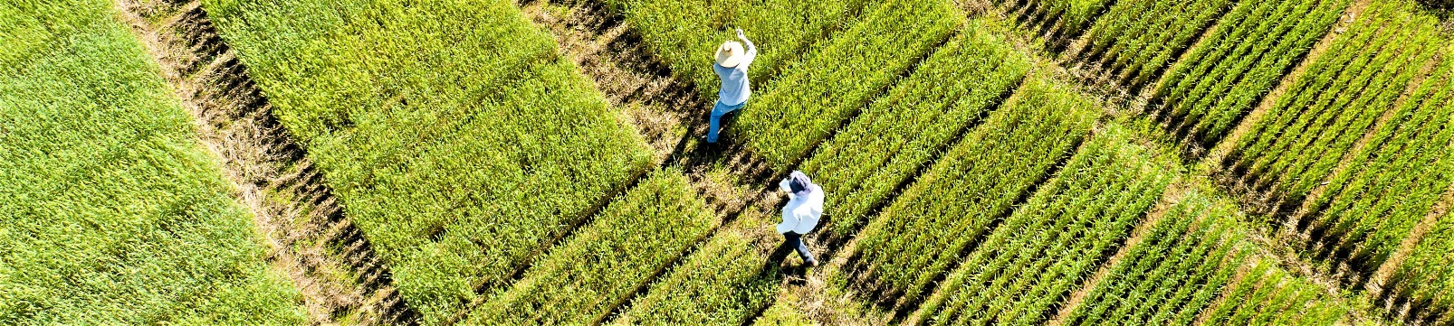

2023-24 KENTUCKY WHEAT VARIETY ENTRY FORM

Company:

Submitted by:

Email:

Eight wheat trials (7-grain & one forage) will be conducted with 4 reps per trial. Varieties are additionally evaluated for straw yield and cover cropping/winter grazing potential, Metribuzin tolerance and rated for disease reaction.

 | Brand/Entry Name(s)° |  | Seed Treatments
1
2
3
4
5
6
7
8
9
10
11
12
13
14
15

° If we have previously tested this entry under a different ‘experimental’ name, please indicate.

Entry fee: entries @ $500 per entry = $ = Total Due

Send 10 lbs seed, and email entry form by September 24, 2023. Contact Bill Bruening for late entries/substitutions.

Send seed to: Send check (payable to University of Kentucky) to:
Bill Bruening - Loading Dock Attn: Bill Bruening
1100 S. Limestone St. UK - Plant and Soil Sciences
Agriculture Science Center North 425 Plant Science Bldg.
Lexington, KY 40546-0091 Lexington, KY 40546-0312

Please email entry form to - bruening@uky.edu – (859) 351-9236

